
Energy in Fuel Investigation

In groups of 2-3, follow the instructions to complete the following investigation:

Your task is to investigate the energy amount of different fuels.

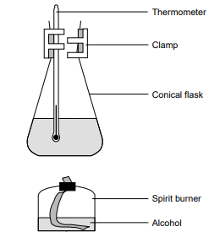

Method:
- Set up the apparatus as shown in Figure above.
- Use the measuring cylinder to measure out 50 mL of water. Add it to the conical flask.
- Weigh the spirit burner (and lid) containing the kerosene and record the mass.
- Record the initial temperature of the water using a thermometer.
- Place the spirit burner under the conical flask and light the wick.
- Allow the kerosene to heat the water so the temperature rises by about 40 ⁰C. Start the timer and stop it once a 40 ⁰C temperature rise has been reached.
- Replace the cap to extinguish the flame.
- Reweigh the spirit burner and cap and work out the mass of kerosene used.
- Repeat the process using ethanol, paraffin, and methylated spirits.
- Record the data in the table.

INDIVIDUALLY write a laboratory report for your investigation using the template on the following page

 |  | Mark
Title | - Title relevant and concise | /1
Aim and Hypothesis | - Aim is clear and concise  - Hypothesis relates independent and dependent variables | /2
Variables | - Independent variable is identified  - Dependant variable is clear and includes units of measurement  - 3-5 controlled variables identified | /3
Results | - Table includes title which relates variables  - Columns relate to independent and dependent variables and include headings with units  - Repeat trials or replicates, averages | /3
Discussion | - Results summarised and patterns identified  - Explanation of results using scientific knowledge (2)  - Difficulties or sources of error identified  - Specific suggestions for improvement or further experimentation | /5
Graph | - Graph title relates variables  - Graph type appropriate for data  - Axis correct orientation and labelled, including units  - Appropriate size and scale | /4
Conclusion | - Summary of findings  - Hypothesis supported or not. | /2

Total: /20

